MSML-650 - Cloud Computing - Lab 1 Screenshot
Name: Pragati Rao
UID: 121332776

Screenshot 1: SSH terminal connection

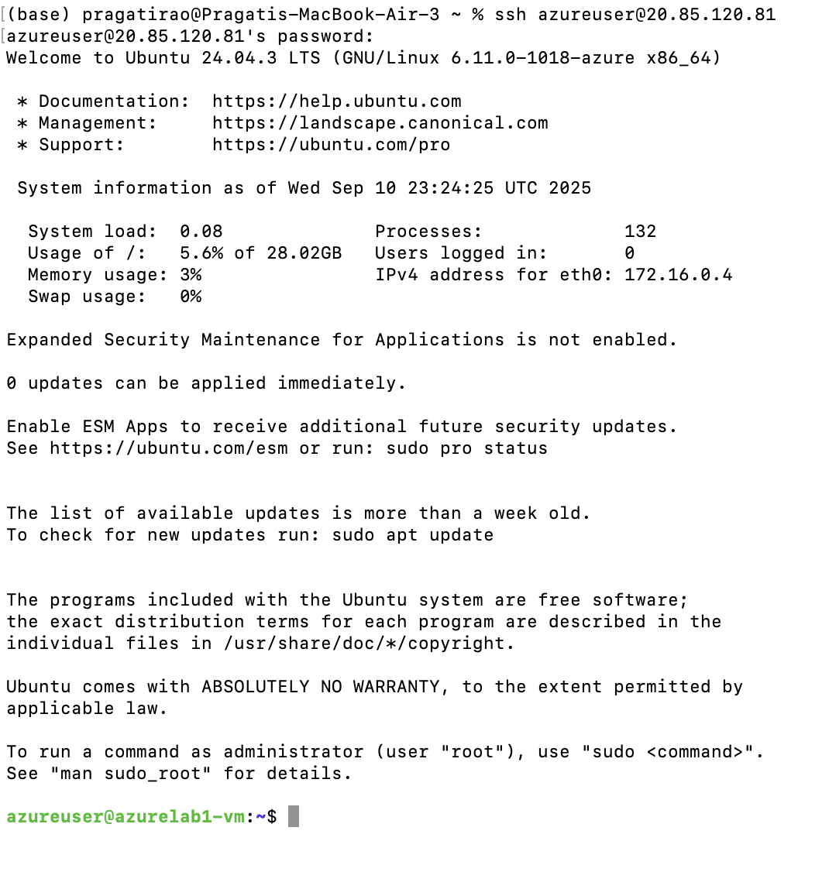

Screenshot 2: VM Desktop
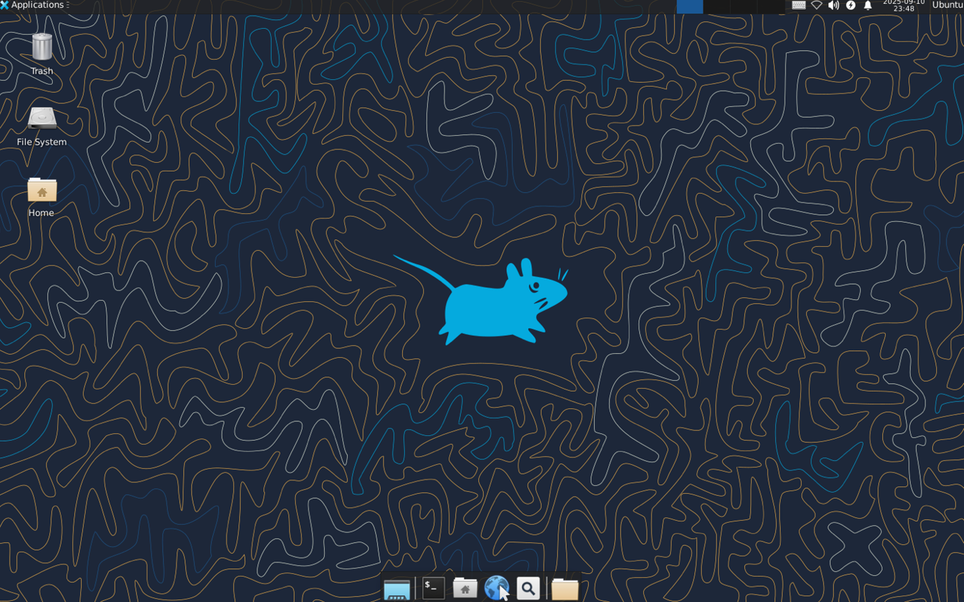
Screenshot 3: VM Insights monitoring data
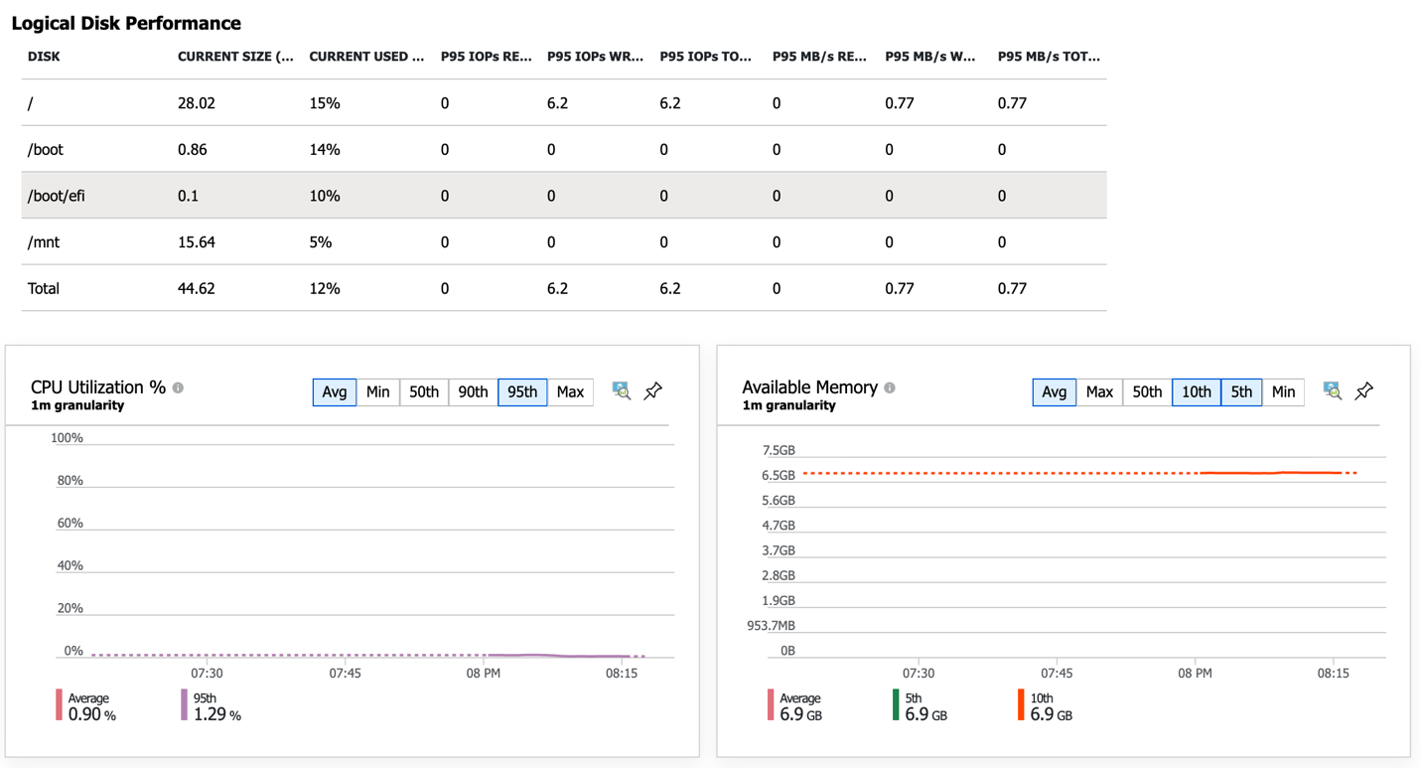
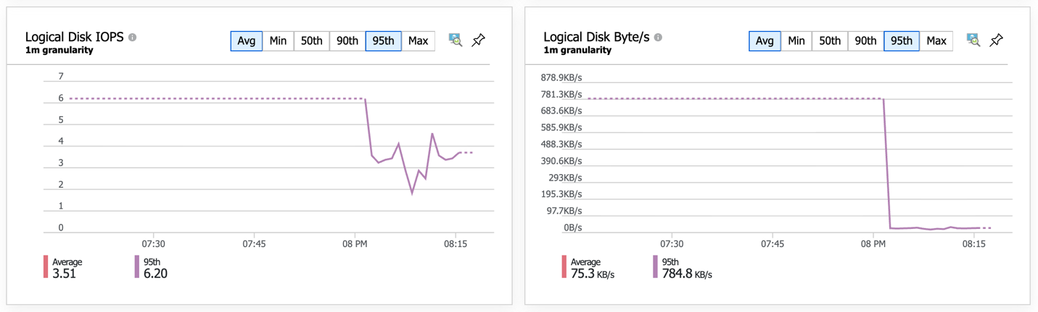
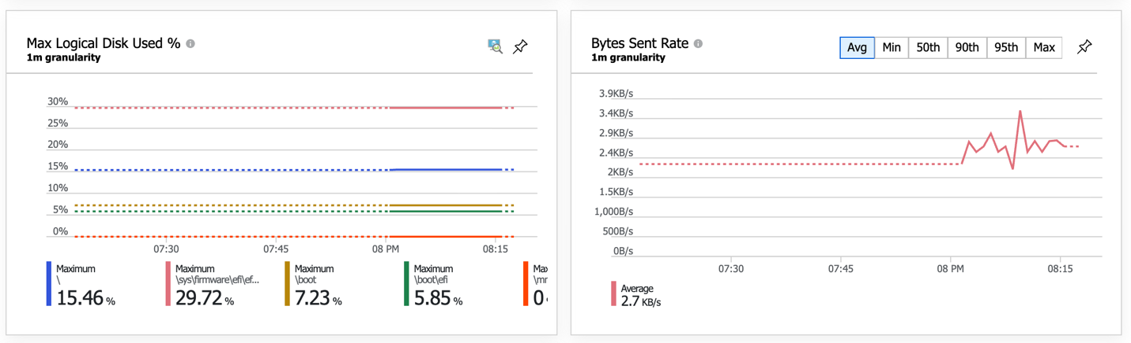
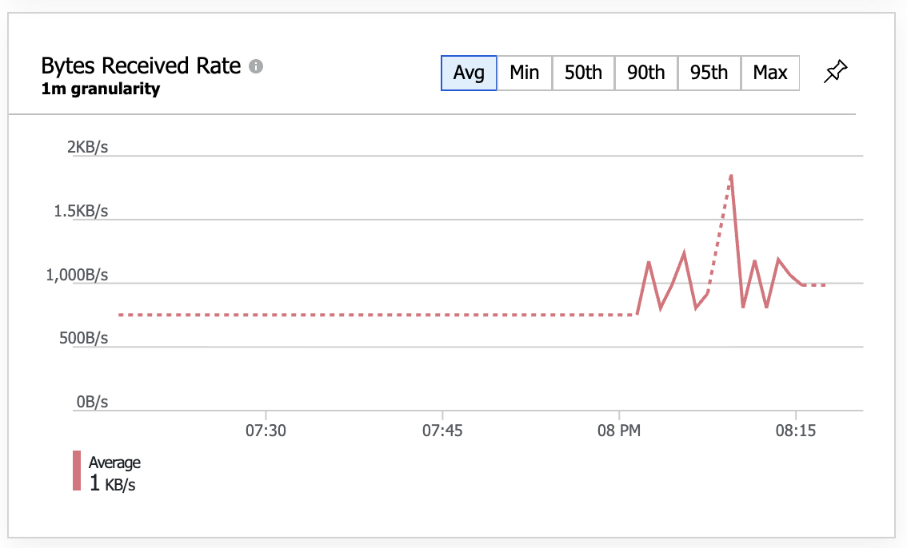
Screenshot 4: Blob Container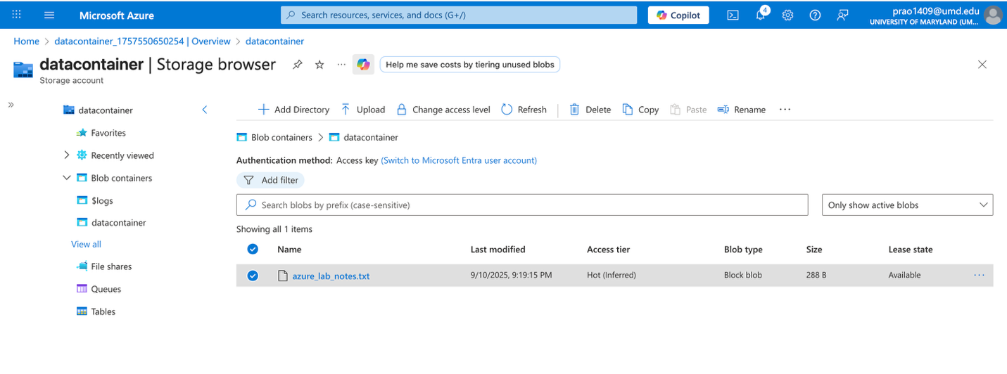
Additional Screenshot:
Screenshot 4.1: Generate SAS Token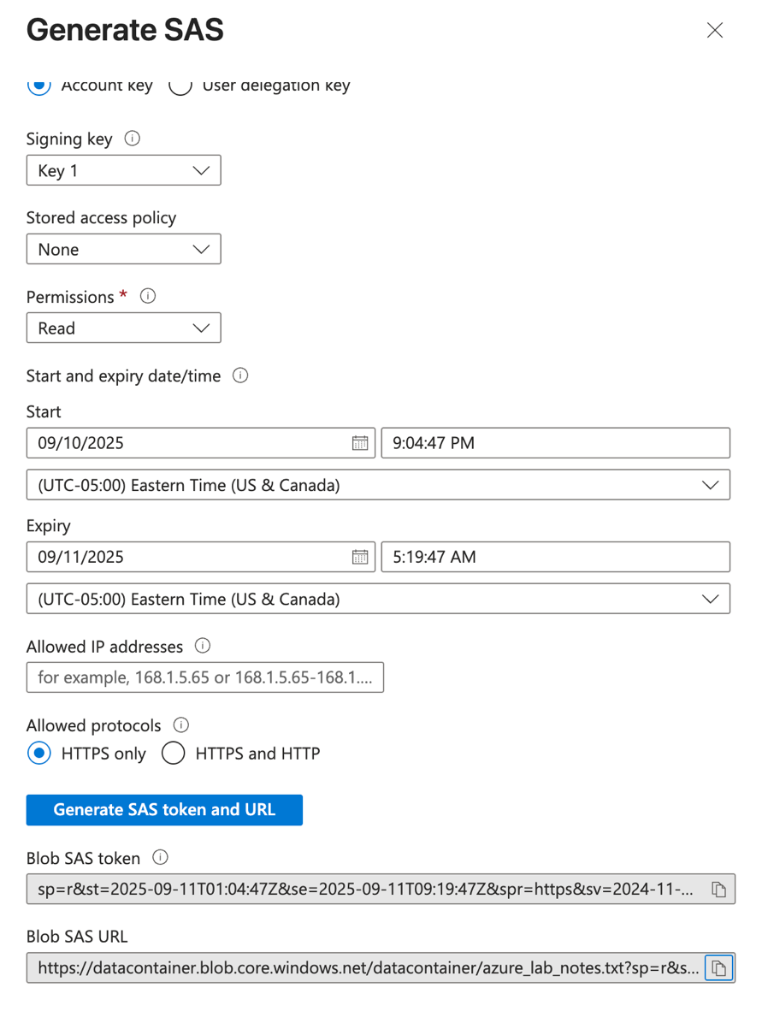
Screenshot 4.2: SAS URL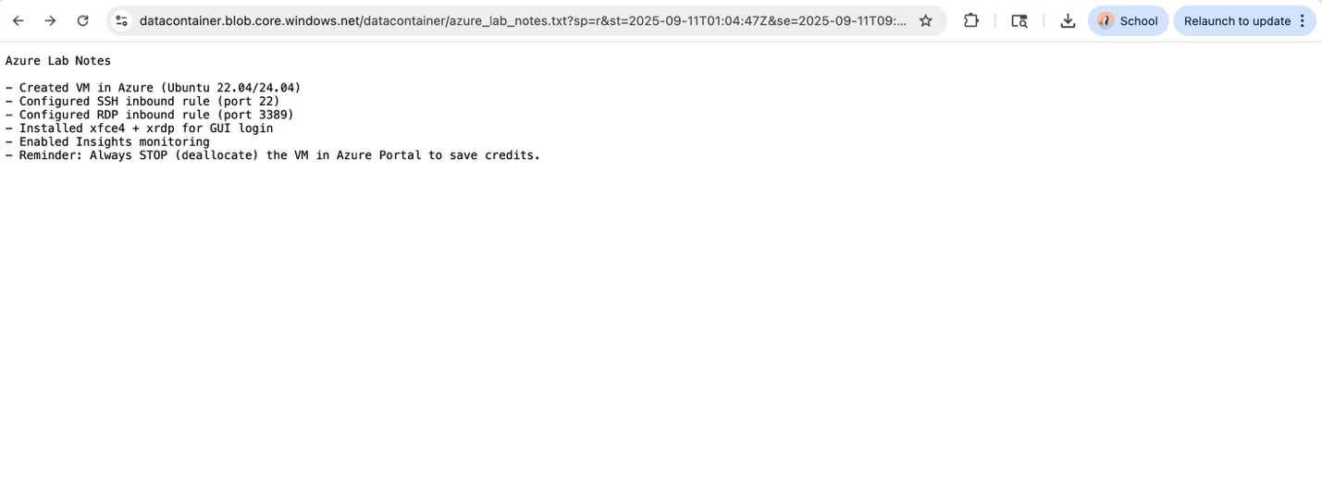
Screenshot 4.3: Blob without the portion after “?”
